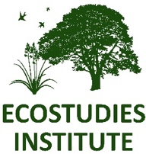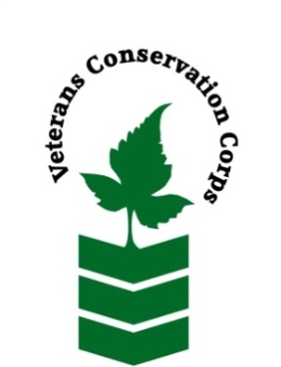 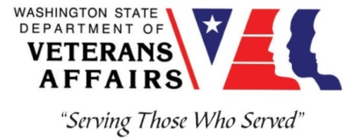

*900 Jefferson St. SE*

*P.O. Box 1614, Olympia, WA 98501*

*www.ecoinst.org*

**­­­­­­­­­­­­­­­­­­­­­­­­_____________________________________________________________________________________**

**Veterans Conservation Corps Crew Internship**

**with**

**Ecostudies Institute**

**Location:** Olympia, WA with travel to sites in rural Thurston, Lewis, and Grays Harbor counties

**Compensation:** $3200/month for a full-time internship (40 hours/week)

**Work Hours:** Monday-Friday, 8:00am-4:30pm

**Duration**: 1 year, with possibility of extension

**Start Date:** April 2025. Position will remain open until filled.

**Position Description**

We are seeking a Veterans Conservation Corps (VCC) member to assist with the monitoring and restoration of rare prairie habitat across the Chehalis watershed (Thurston, Lewis, and Grays Harbor counties) in southwest Washington. The VCC member will work with a small crew to enhance wildlife habitat, remove invasive weeds, monitor plant/pollinator/bird communities, promote responsible grazing practices, and educate landowners about conservation programs. There will also be opportunities to travel and work in diverse field sites across Washington state. This position requires a sound work ethic, strong interpersonal skills, and a positive attitude during long field days. We are committed to providing a meaningful experience for the VCC member and will support any veteran-specific needs that are appropriate to each Individual’s capabilities and condition during enrollment in program.

**Responsibilities**

VCC member will serve with Ecostudies Institute and partnering agencies to carry out the following duties:

* Restore native prairie habitat through mowing, prescribed burning, invasive species removal (e.g., herbicide application, brushcutting, etc.), and native plant seeding
* Collect field data on plant, pollinator, and bird communities
* Support project implementation through field season preparation, literature reviews, and data entry/management
* Communicate with landowners about conservation grazing techniques and conservation programs

**Training Opportunities**

On the job training will be provided to successfully complete position duties. Additional opportunities for formal trainings and professional development may include:

* First Aid/CPR
* NWCG Firefighter type II (Crew member) Certification
* Washington State Pesticide Applicators License
* Plant identification
* Habitat restoration and vegetation management techniques
* Chainsaw and brush cutting training
* Environmental conservation conferences/symposiums/workshops
* Grazing management
* Whole Farm Planning and Agricultural Entrepreneurship
* Growing your veteran-owned small business
* Veteran Peer Support Training
* Posttraumatic Growth Training
* PTSD/TBI/Mental Health/ Suicide Awareness & Prevention
* Other trainings/certifications as available and desired by intern

**Requirements**

* Must be a veteran of the United States Uniformed Services to be eligible for this position
* Must currently possess (or have the ability obtain) a valid driver’s license (or have reliable transportation to downtown Olympia office and field sites in rural areas)
* Must be able to perform strenuous field work on uneven terrain in adverse weather conditions
* Interest in learning about native plants, grazing techniques, and conservation programs
* Must be able to follow oral and written directions

**Preferred Knowledge, Skills, and Abilities**

* Plant identification skills, including common weeds (or eagerness to learn)
* Basic computer skills (e.g., use of web browsers and commonly used software such as Microsoft Office)
* Attention to detail
* Experience working on a crew to complete time-sensitive projects
* Experience implementing safety practices in the field with and without supervision
* Experience operating hand tools and power tools
* Comfortable working with chemicals such as herbicides and fertilizers
* Able to lift up to 50-lbs
* Able to operate motor vehicles and haul a trailer
* Comfortable speaking to landowners and other members of the public about projects
* Motivated and enthusiastic to work and learn

**Apply**

All applicants must pass a background check.

To apply for this internship, **email a copy of your DD214 or service discharge certificate, a copy of your driver license, a resume, and a cover letter** explaining your interest in this internship to:

Kim Pham

Veterans Conservation Corps Program Manager

kim@dva.wa.gov

**Questions?**

To learn more about the Veterans Conservation Corps, contact:

Kim Pham

Veterans Conservation Corps Program Manager

kim@dva.wa.gov

For more information about Ecostudies Institute, contact:

Melissa Habenicht

Ecostudies Institute

[mhabenicht@ecoinst.org](mailto:mhealy@thurstoncd.com)

423-237-2820

*Ecostudies Institute is an Equal Opportunity employer. Personnel are chosen on the basis of ability without regard to race, color, religion, sex, gender, national origin, disability, marital status or sexual orientation, in accordance with federal and state law.*